**Issues:** More Housing Options

**Keywords:**

| House, housing, apartment, rentals, affordable, rent, lower rent, more housing options, accessible housing, off-campus housing, eco-housing, housing variety |
| --- |

**What are respondents of this category saying in Q1-5?**

**Removed words:** 'community', 'town', 'small', 'people', 'college', 'grinnell', 'job'

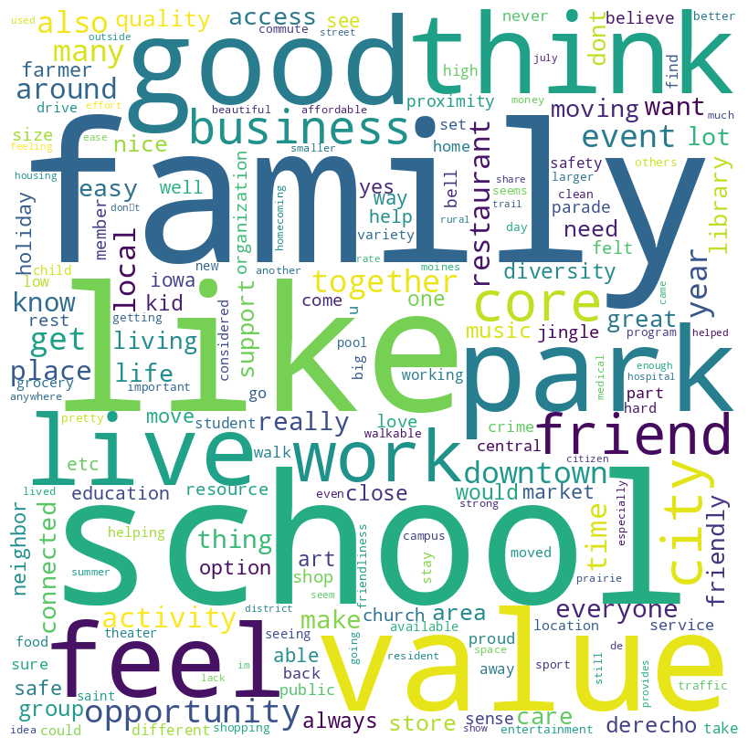

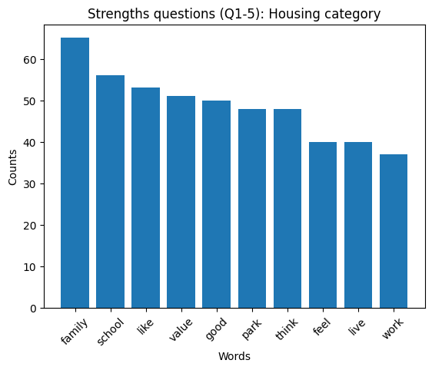

**Average sentiment of respondents of this category:**

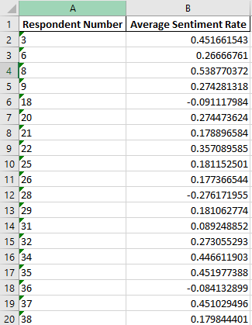

**Full file at: Final Deliverable > Issues Analysis & Deliverables > average_sentiment_housing.xlsx**

**Clustering based on response to each question:**

Question 1: What makes you glad to live in Grinnell?

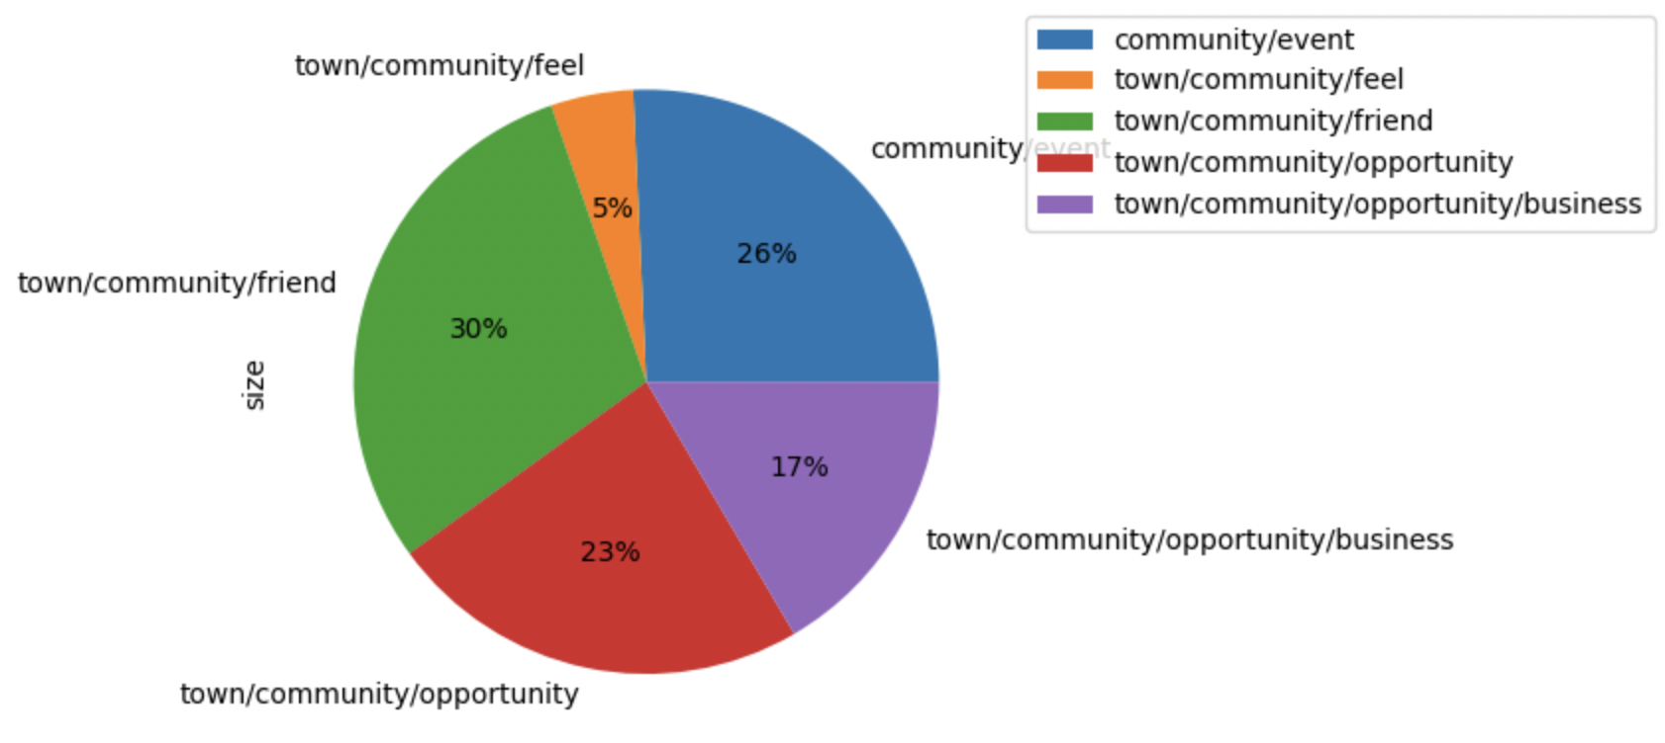

Question 2: What things have the greatest positive impact on your quality of life in Grinnell?

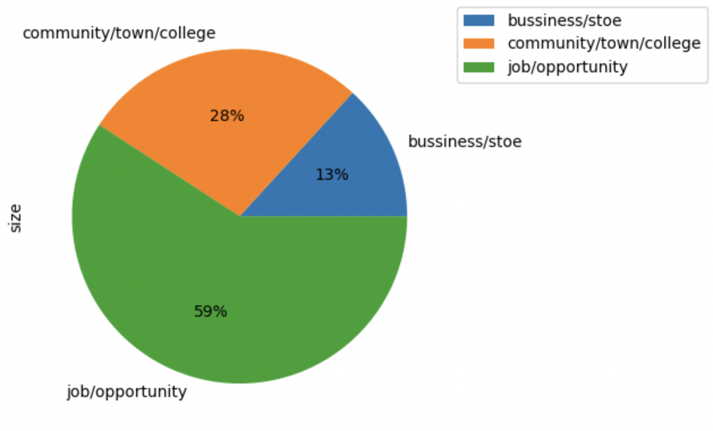

Question 10: What things have the greatest positive impact on your quality of life in Grinnell?

